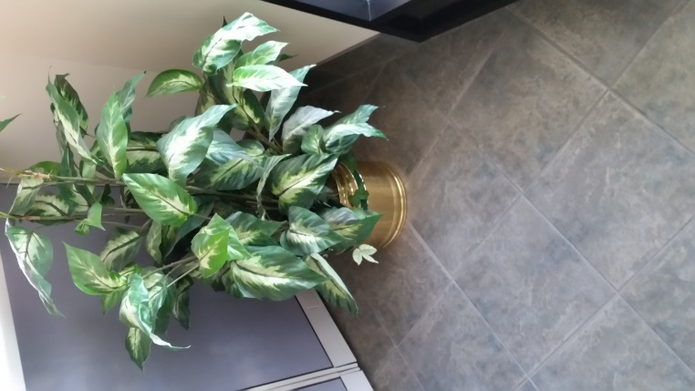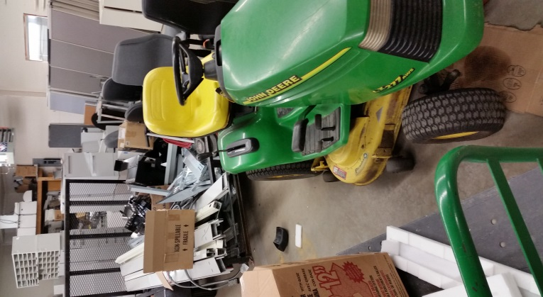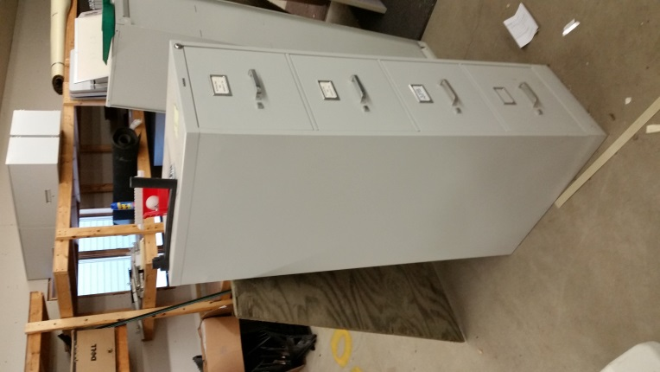

When it comes time to sell the JD tractor or trailer, I am interested

At this time, the Tractor and Trailer will be retained.

You can have the plant.

The File Cabinet would be $20.00

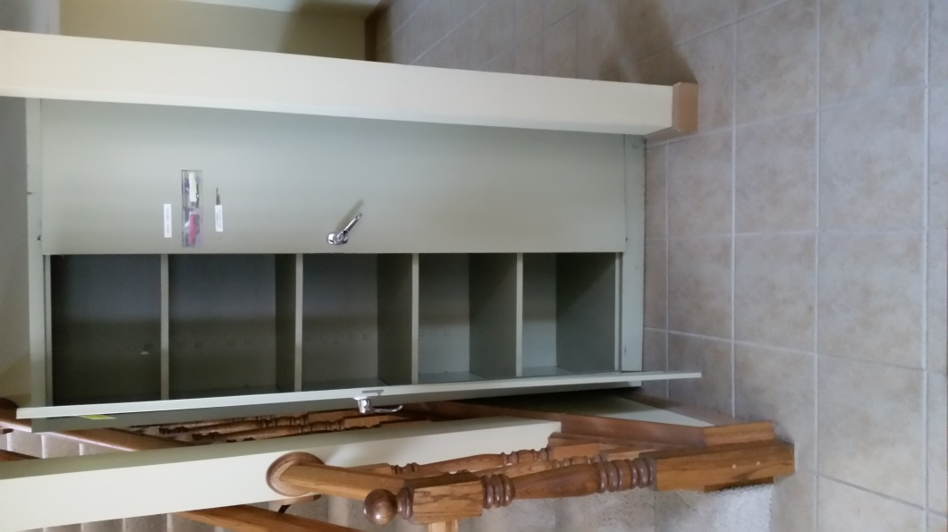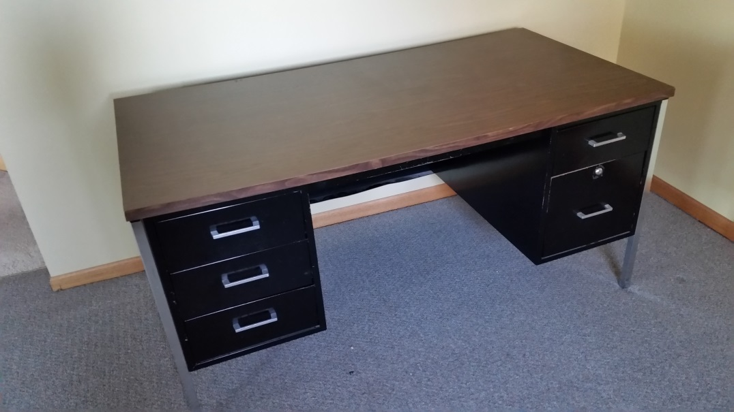Metal Cabinet is Justin’s. The Metal Desk is $10.00

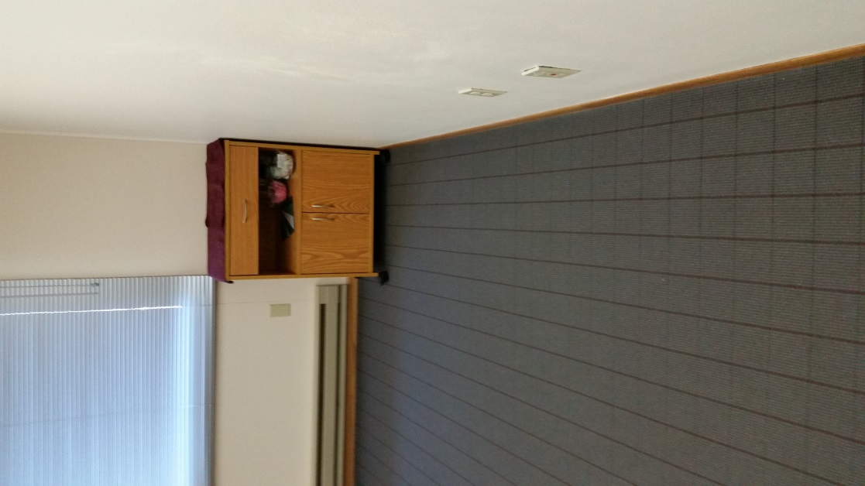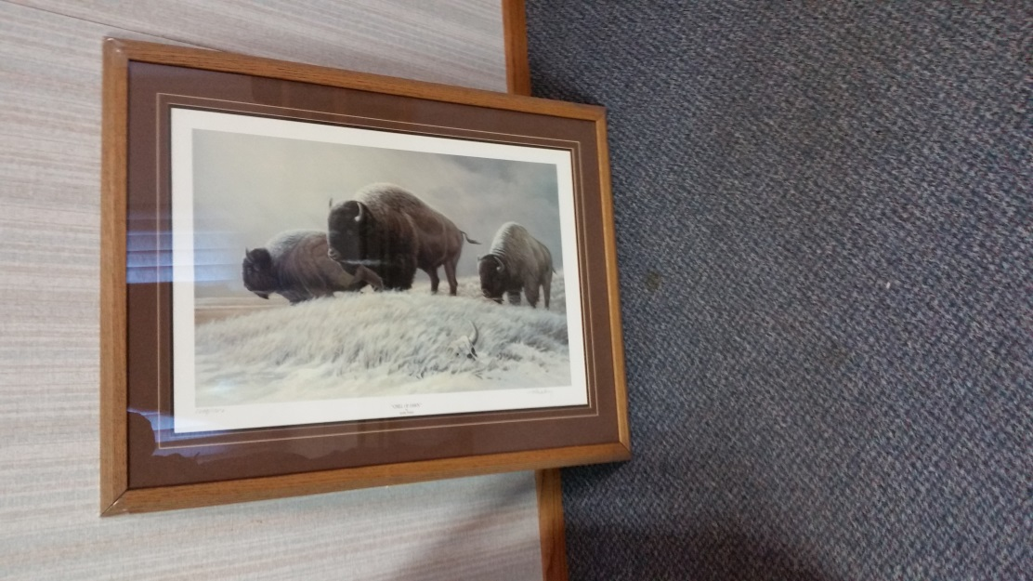Microwave Stand $15.00

You can have this picture.

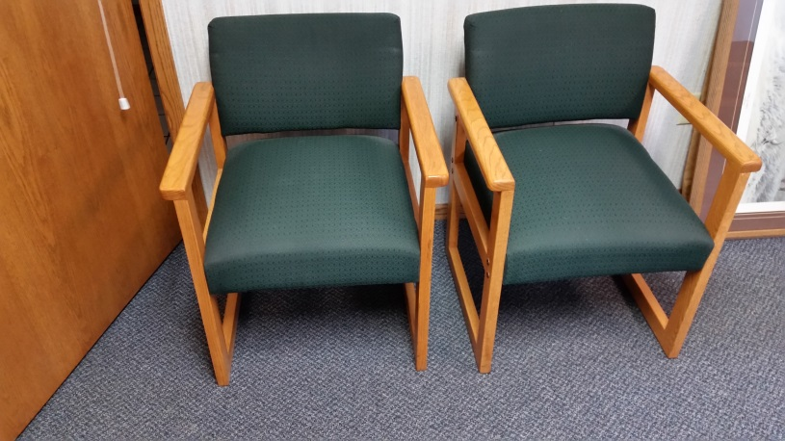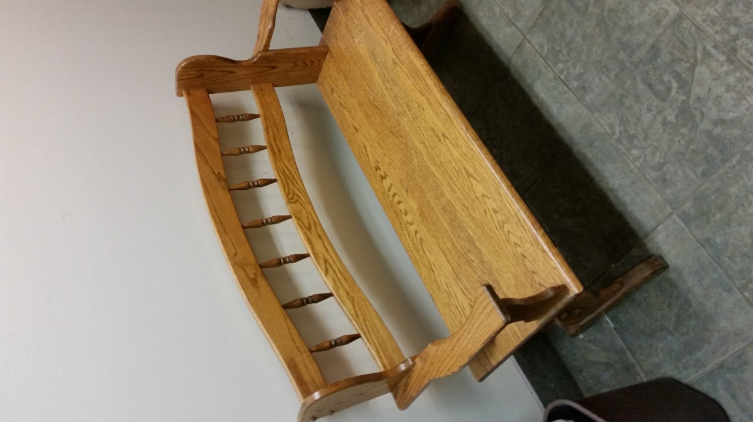Green Chairs will be sold as a Set of Six if we sell them; $30.00 each.

The Bench is spoken for.

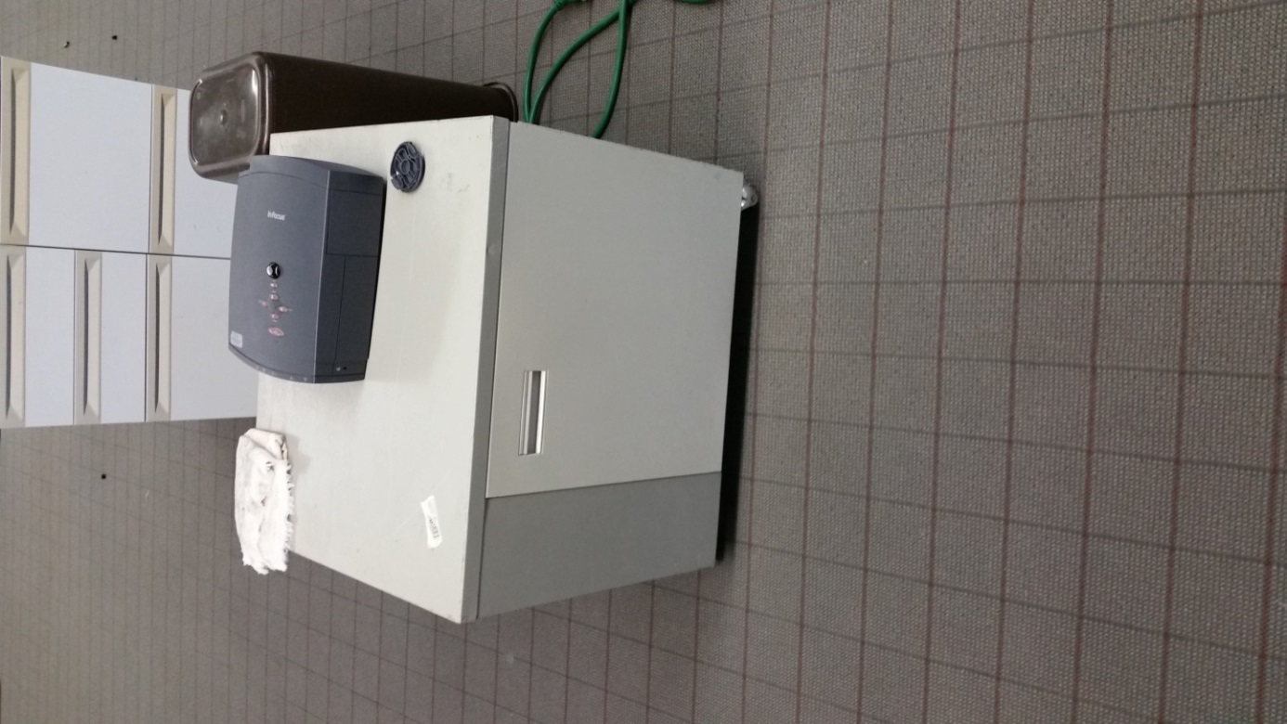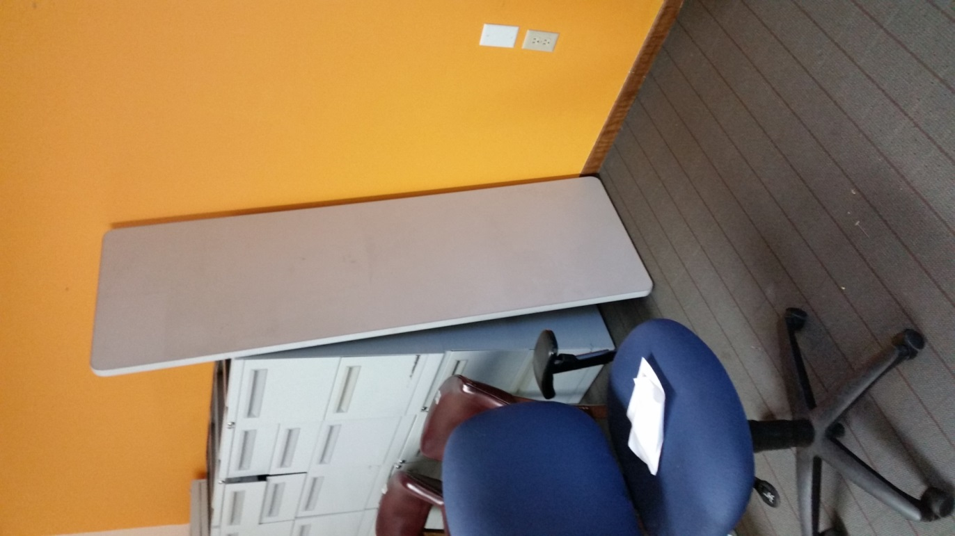Are you looking at the Cabinet or the Projector?

Also, is the Work Surface what you’re looking at?

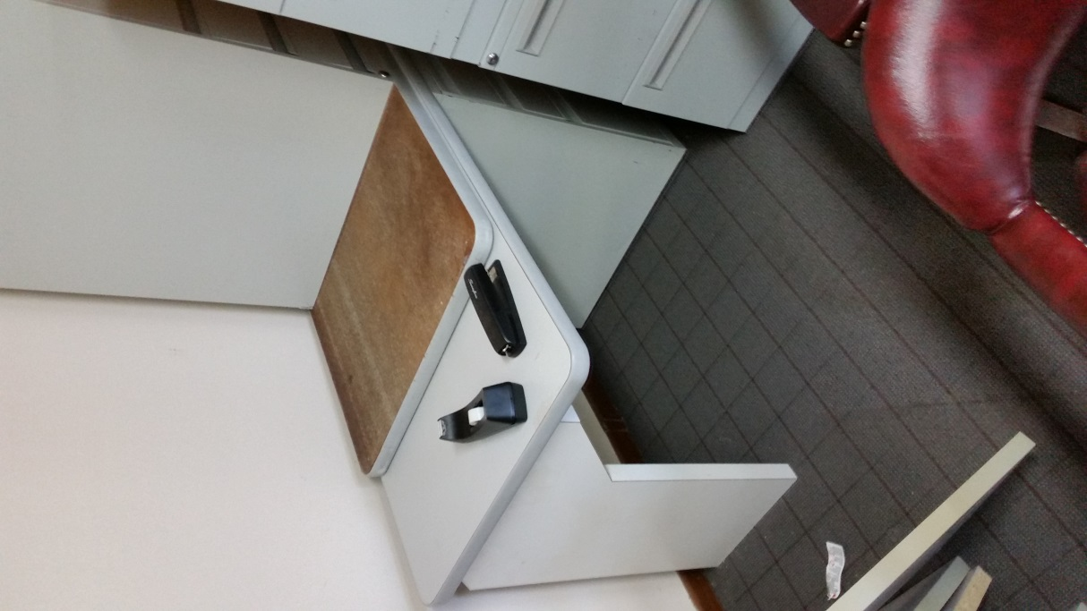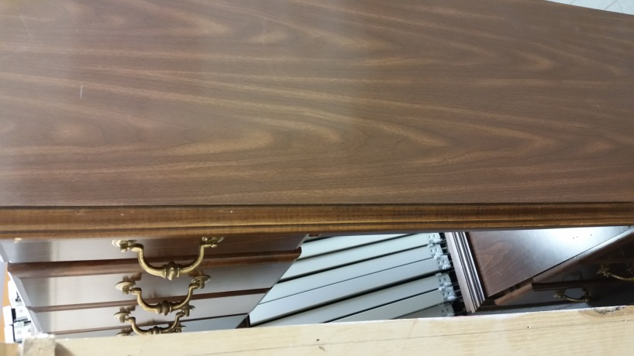You can have the Stapler and Tape Dispenser. The Desk is $20.00

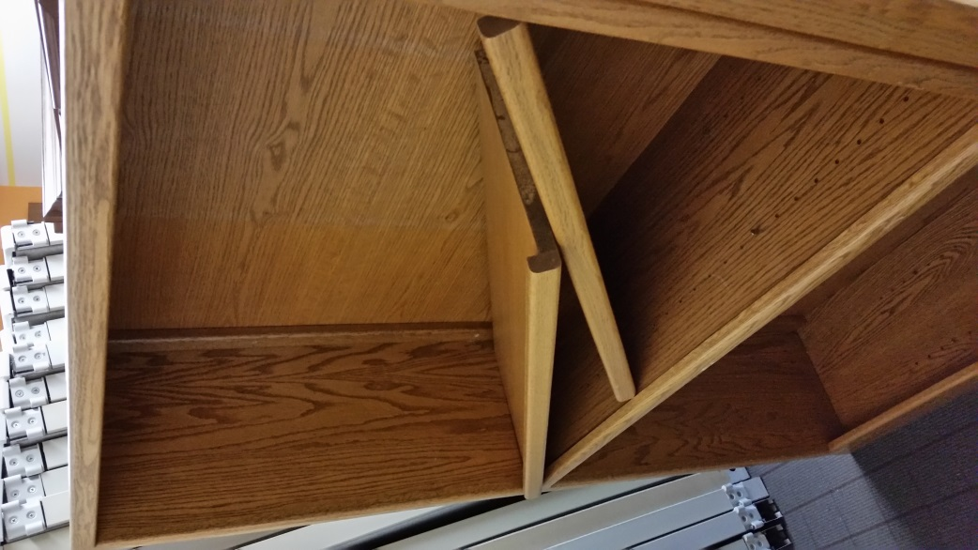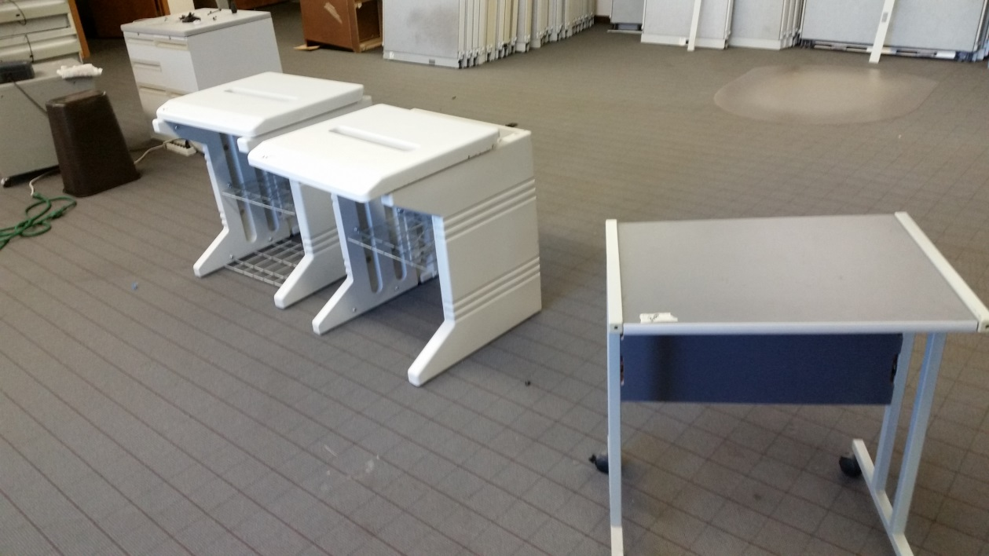The shelf is Tony Johnson’s.

The Printer Stands are as marked.

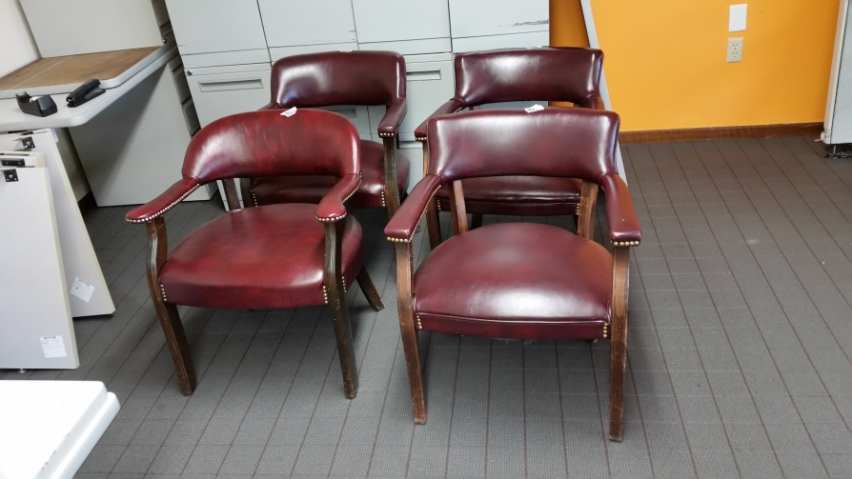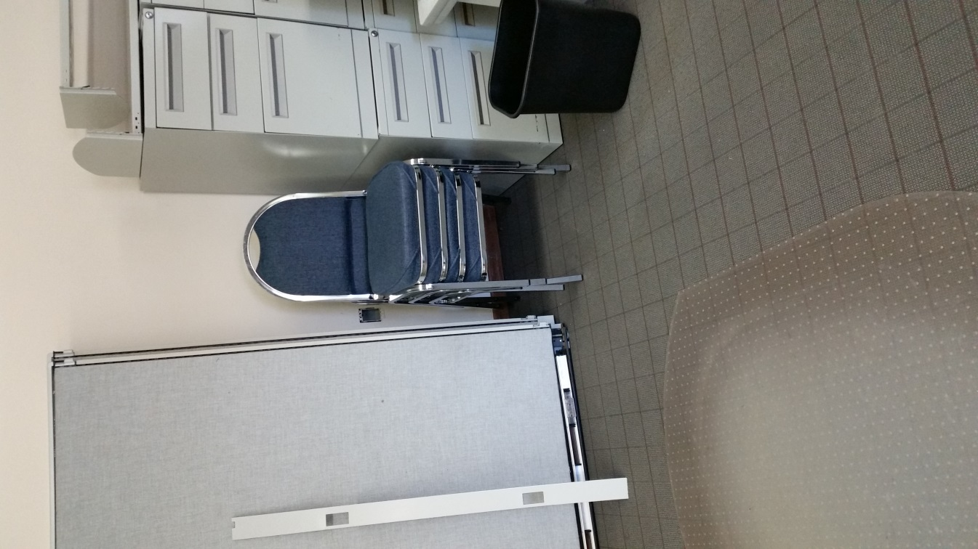 Keeping the stack chairs for now.

Maroon Chairs are $15.00 each; unless marked elsewise.

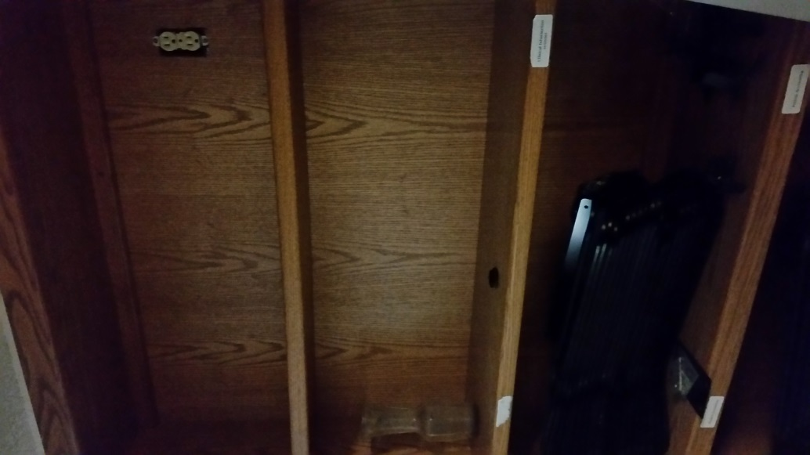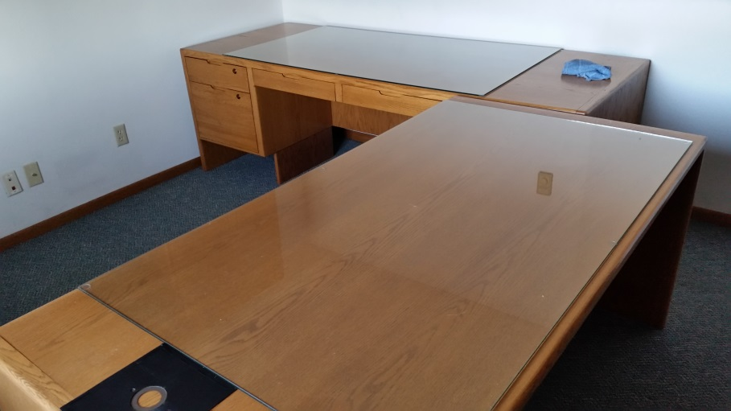

The Wood Cabinet would be $40.00

The Executive Desks would be $250.00 for the Set.

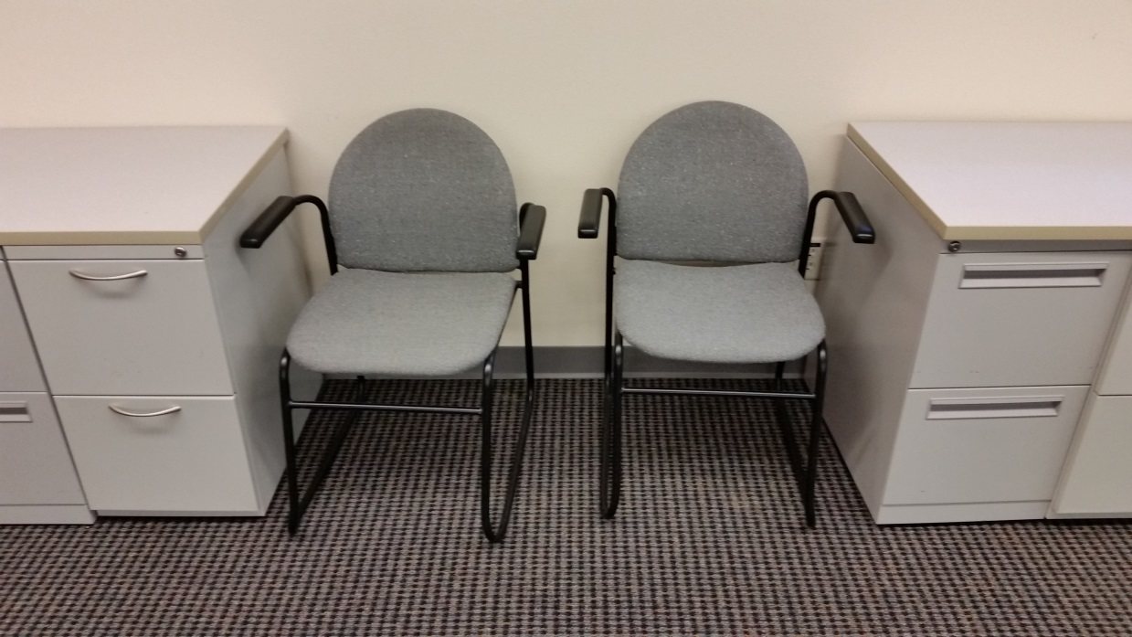Sled Chairs are $15.00 each.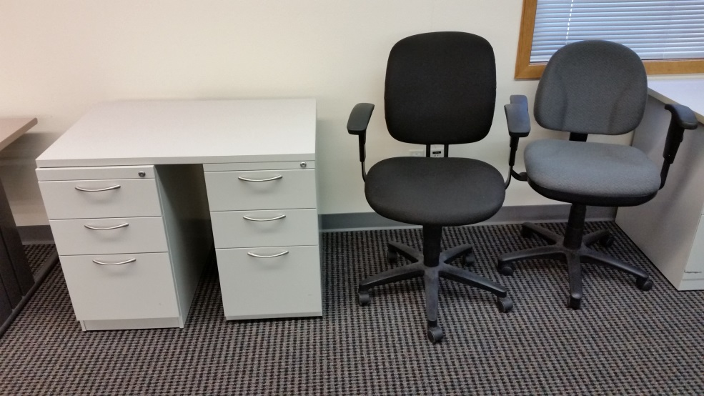We have been selling office chairs for $10 - $15 each, depending on condition. 2 & # Drawer Cabinets are $10 per each unit. Work Surfaces are $10 to $20 per each, depending on size. We will not be selling much more of the Cabinets and Work Surfaces until I get an answer from Klick / Bailey on their interest.

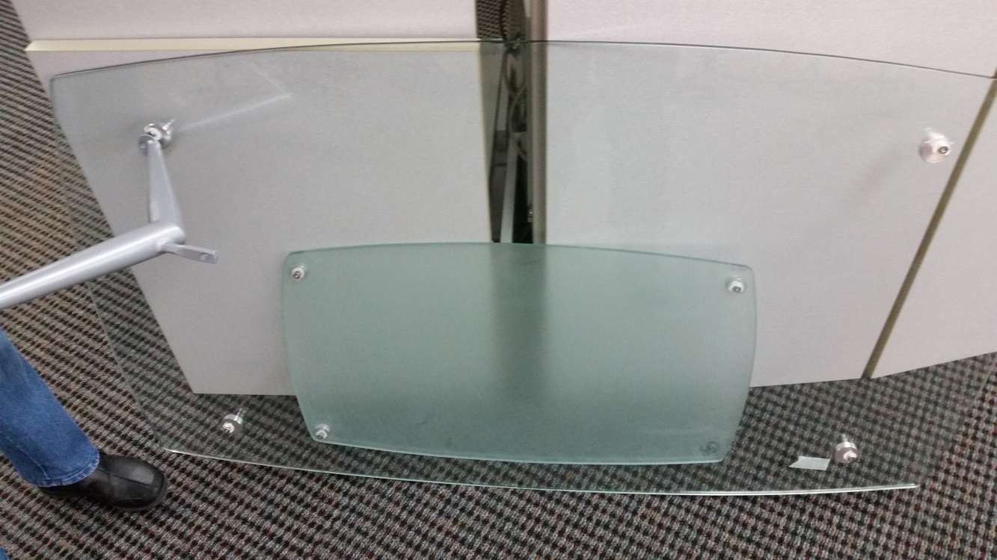

You can have this Coffee Table (needs repair).